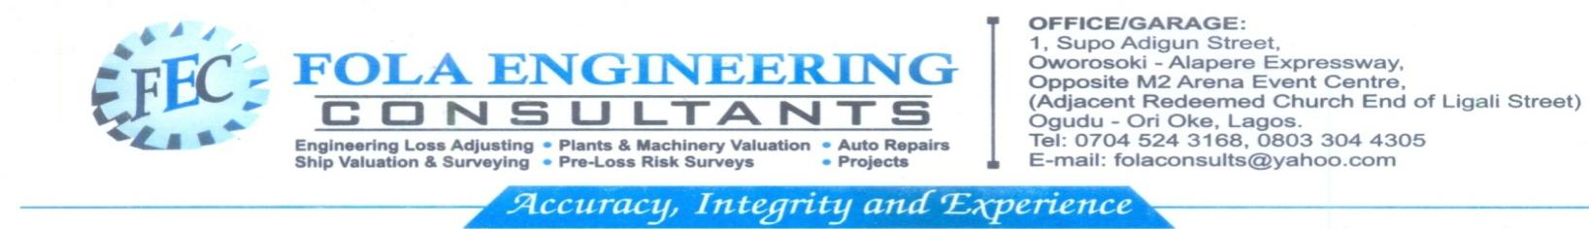
Our Reference No: FEC/MOT/06/23/5509

19th June, 2023

The Managing Director,
FNIB Insurance Brokers & Consultant Limited,
52, Itolo Street,
Surulere,
Lagos.

Dear Sir,
RE: INSPECTION REPORT ON TOYOTA COASTER BUS WTH REG.NO: KSF 82 XV(2014 MODEL)
CLAIM NO: T.B.A
CHASSIS NO: JTGFK5185G4029022
DATE OF APPOINTMENT: 11th June, 2023
DATE OF INSPECTION: 16th June, 2023
INSURED: C & I LEASING PLC
INTRODUCTION
Following your directive, we carried out physical inspection of the above stated vehicle on 16th June, 2023 at the workshop premises of Musibau Azeez Nigeria Enterprises, No 32, Imam Raimi Street, New Makoko-Yaba, Lagos. Photographs of the vehicle taken at the site of our inspection are attached for your record purposes.

CAUSE AND EXTENT OF DAMAGE
The insured’s vehicle was impact at the rear and possibly thereafter swerved to impact the front-end.

Physical inspection confirmed that the impact of the accident damaged the front bumper, rear exhaust mountain, rear view mirror, left side mirror and as well cracked the rear lights of the vehicle while the rear bumper was reportedly missing at the scene of the accident. Our further inspection revealed that the front panel, right side body panel and left front body panel suffered repairable damage. Details of replaceable damaged parts are as follows:

- Front bumper - Rear bumper(missing)
- Bumper brackets - Rear light set
- Rear trafficators - Rear exhaust mountain
- Water spray jet - Right wiper stick
- Rear view mirror - Left side mirror.

REPAIR ESTIMATE/ADJUSTMENT
An estimate of repair in the sum of ₦1,433,950.00 from Musibau Azeez Nigeria Enterprises was checked item by item and found unrealistic in materials. We noticed that the front/rear wiper blades and rear C-caution quoted in the estimate were not relevant to the accident while the prices quoted for the affected parts are on the high side. We had discussion with the repairer over the inflated estimate and after a long discussion, we concluded with the following deductions;

- Front bumper & bumper bracket less ₦55,000.00
- Rear bumper & bumper bracket less 45,000.00
- Rear light set less 20,000.00
- Rear exhaust mountain (2) less 20,000.00
- Rear view mirror & left side mirror less 35,000.00
- Delete front & rear wiper blade less 12,000.00
- Delete C-caution less 5,000.00
- Wiper stick less 10,000.00
- Wiper water jet spray less 12,000.00
- Panel beating materials less 70,000.00
- Painting materials of the whole body of the vehicle
(₦285,150.00) less 30% betterment contribution 85,785.00
- General Labour less 90,000.00
Total Reduction ₦459,785.00

SUMMARY
- Original Estimate = ₦1,433,950.00
- Total Reduction = 974,165.00
- Revised Estimate = 459,785.00
- Policy Excess = T.B.A

PRE-ACCIDENT VALUE
The pre-accident open market value of the vehicle would be about ₦18,000,000.00.

RECOMMENDATION
Repairs is economical on revised estimate of ₦974,165.00 and same less applicable policy excess is recommended for settlement. Our survey report no-07881 dated 16th June, 2023 was issued subject to insurer’s approval and duly countersigned by the repairer is attached.

Thank you for your patronage while we assure you of our prompt and qualitative services always.

Bill in respect of the inspection fee/expenses is attached for your prompt settlement.

Yours Truly,
FOLA ENGINEERING CONSULTANTS

E.A ALADE
C.E.O

