
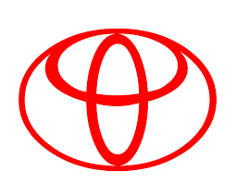
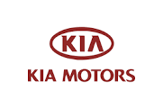
Specialized on all types of American, Japanese,
Korea and European Vehicles.
OFFICE: 91 Okpu-Umuobo Road, Opp. Union Bank Aba-Owerri Road, Aba
PHONE: 08036737235
14/7\2025
Our Ref:…………..………….……..Your Ref:……………..…….……………Date: ……………

Fleet Officer,
C & I Leasing – Equipments Rentals,
Leasing House,
Off Oginigba, Elekahia Link Road,
Trans –Amadi, PH,
Rivers States
Dear Sir.

JOB 61609 MITS L200 AAA 533/ABM 445 AA MILEAGE 334100

S/N | DESCRIPTION | AMOUNT
1. | Engine oil (one and half gallons) | 35,000
2. | Oil filter | 5,000
3. | Brake master cylinder kit | 20,000
4. | Upper clutch kit | 15,000
5 | Down clutch kit | 10,000
6 | Hydraulic | 5,000
7 | Rescue from Ogbaru | 15,000
9 | LABOUR CHARGE | 17,000
 | TOTAL | 122,000

TOTAL IN WORDS: (One hundred and twenty twothousand Naira Only)

AGBO ROMANUS ANAYO
M/D

