
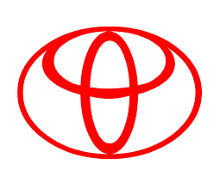
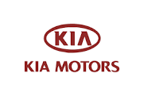
Specialized on all types of American, Japanese,
Korea and European Vehicles.
OFFICE: 91 Okpu-Umuobo Road, Opp. Union Bank Aba-Owerri Road, Aba
PHONE: 08036737235
28/6/2025
Our Ref:…………..………….……..Your Ref:……………..…….……………Date: ……….…………

Fleet Officer,
C & I Leasing – Equipments Rentals,
Leasing House,
Off Oginigba, Elekahia Link Road,
Trans –Amadi, PH,
Rivers States
Dear Sir
JOB 60568 TOYOTA HILUX LSD 454 XM MILEAGE 305107

S/N | DESCRIPTION | AMOUNT
1. | Left front wheel bearing | 25,000
2. | Left front wheel bearing oil seal | 9,000
3. | Grease | 5,000
4. | Rescue at owerri (logistics) | 15,000
5. | LABOUR CHARGE | 15,000
8 | TOTAL | 69,000

TOTAL IN WORDS: (Sixty nine thousand Naira Only)

AGBO ROMANUS ANAYO
M/D

